NCVHS Predictability Roadmap
  - Lantana Comments—Amended
December 20, 2018
(post hearing)

Prepared for National Committee on Vital Health Care Statistics: Subcommittee on Standards

Lantana Consulting Group
PO Box 177
East Thetford, VT 05043
www.lantanagroup.com
Liora Alschuler
Chief Executive Officer
liora.alschuler@lantanagroup.com
Contents
1 Our Vantage Point on Standards & Adoption 1
2 General Comments 2
3 Response to Questions 2
3.1 Would these recommendations as a whole improve the predictability of the adoption of administrative standards and operating rules? 2
3.1.1 Education & Outreach 2
3.1.2 Policy Levers 3
3.1.3 Regulatory Actions 3
3.2 What additional recommendations are critical to achieve predictability? 4
3.2.1 Realize Agile Practices with Continual Development and Test 4
3.2.2 Simplify and Unify Stakeholder Engagement 4
3.2.3 Define the Philosophical Sweet Spot that Balances Stability with Innovation 5
3.2.4 Create a Business Model Founded on Greater Collaboration between SDOs and Regulators 6
3.3 What is the value proposition of each recommendation and what improvements to the current state do you believe will arise from each recommendation/group of similar recommendations? 6
3.4 Are there potential unintended consequences? What are those and how can they be mitigated with modifications to the recommendations? 6
4 Post-Hearing Comments 7
4.1 Modeling agile standards development and implementation 7
4.2 Integration of administrative and clinical content 7
4.3 Addressing heterogeneity among stakeholders 7
4.4 Incomparable comparisons 8

Figures
Figure 1: SDO and Regulatory Process Waterfall Diagrams 4
Figure 2: Stakeholder Engagement in Standards Rulemaking, Current State 5

Our Vantage Point on Standards & Adoption
We would like to thank the NCVHS Subcommittee on Standards for the work they have done to improve and accelerate the development, adoption, and implementation of standards and operating rules and for the opportunity to comment on their work here. To provide perspective on our comments, we start with a brief summary of our work in this area.
Lantana’s principals have led or supported several standards in use today, starting with the Clinical Document Architecture (CDA), the Continuity of Care Document (CCD), the Health Story Project, and the Consolidated CDA (C-CDA), which was built on the Health Story work, and Quality Reporting Document Architecture (QRDA). Most recently, we led the development of the CDA-on-FHIR specification, which is a critical path component for the transition from CDA to FHIR. Our Chief Innovation Officer, Rick Geimer, was elected recently to the HL7 FHIR Infrastructure Work Group and we hold Work Group Co-Chair positions on Clinical Quality Improvement and Structured Documents.
We have represented stakeholder interests in the design, development, ballot, and subsequent publication of standards for the Office of the National Coordinator for Health Information Technology, the Centers for Medicare & Medicaid Services, the National Quality Forum, the Centers for Disease Control and Prevention, the National Institute of Standards and Technology, and numerous professional societies including the American Society of Clinical Oncology, the Alliance for Pediatric Quality, the Academy of Nutrition and Dietetics, and the Pharmacy Health Information Technology Collaborative as well as for private clients. We have collaborated on tooling and standards development with industry consortia including Integrating the Healthcare Enterprise (IHE) International, the HIMSS EHRA, the Da Vinci Project, the Sequoia Project, the Clinical Data Interchange Standards Consortium (CDISC), the Council for Affordable Quality Healthcare (CAQH) Committee on Operating Rules for Information Exchange (CORE), and the Continua Alliance.
Our track record on moving industry requirements through to publication with a standards development organization (SDO) on a predictable timeline is strong and is based on our experience with and commitment to the consensus process. We have a first ballot success rate that is near 100% when excluding major, de novo efforts, such as CDA itself or C-CDA.
While best known in SDO circles for our support of standards development, we bring to this work the perspective of implementers through our support for vendors and providers working with these specifications and our support for the rollout of programs from CMS and the CDC.

General Comments
“Predictability is an asset in health care operations because it enables more effective planning for the necessary transitions in workflows, business process changes and system updates. Organizations need sufficient time and information to make the right calculations for scope and resources.”
—From the subcommittee report, “Improving Health Care System Efficiency by Accelerating the Update, Adoption, and Use of Administrative Standards and Operating Rules”, pp. 5-6
Lantana strongly supports the move to increase predictability throughout the standards development, review, adoption, and implementation lifecycle. Knowing what is feasible and what is expected are both required to drive improvements to system architecture, design, and execution. In this section we provide a small number of general observations on the questions raised by the subcommittee and in the following section we apply these observations and others to the recommendations and questions raised by NCVHS.
We respect and concur with the findings from the 2017/2018 hearings that engaged standards and business leaders, particularly the imperatives to:
- Avoid “technical debt” and “throw away work”
- Align rulemaking with business, technology, and standards
- Diversify stakeholder engagement in the process
- Ensure a sound financial model for standards development
- Be agile and iterative in the process
- Align administrative and clinical standards and processes
- Integrate empirical testing with cost/benefit analyses throughout the process
Changes that streamline, simplify, and unify SDO and regulatory processes and oversight can pave the way to a predictable national health information technology roadmap.

Response to Questions
In this section we dig deeper into our general observations in response to NCVHS questions.

Would these recommendations as a whole improve the predictability of the adoption of administrative standards and operating rules?

Education & Outreach
Education and outreach can play key roles in the improvement of the SDO and regulatory processes that drive predictability. The three Recommendations (#1, 2, and 7) address transparency, compliance enforcement, and guidance on appropriate use. The corresponding Calls to Action (A, B, E, and F) address barrier identification, policy guidance from WEDI, collaboration to increase and diversify participation, and a commitment to support SDOs through membership and volunteer SMEs.
Juxtaposed in this manner, it is difficult to see how the Calls articulated in the materials addresses transparency or compliance enforcement or comprehensive guidance, if not provided by WEDI.
We believe that more specific guidance is required to address both the limited Recommendations listed under the goal of education and outreach and the wider goals articulated in the earlier hearings.
It would be helpful if each of the hearing findings were addressed directly in Recommendations and each Recommendation were tied to one or more Calls to Action. Once the Calls to Action are tied to specific recommendations, the corresponding Measurements will become easier to identify and assess.

Policy Levers
Policy levers are certainly critical in the development of a predictable roadmap. The Recommendations (#3, 4, and 5) would dismantle the current DSMO and “enable the creation” of a new entity. Without more insight into the Subcommittee’s vision for the new entity, its composition and manner of operation and authority with respect to other stakeholdersit is difficult to comment here.
Additional recommendations (#8 and 9) call to publish regulations within one year of recommendation to the Secretary and to provide resources for education, enforcement, and regulatory processes. Setting a predictable timetable for publication would move the industry to a position of greater predictability. Whether the appropriate timeframe is one year depends on how the process as a whole is reimagined. We comment on this in our additional recommendations (see section 3.2).
Providing adequate resources for program rollout and management seems an obvious requirement and does not require comment.
As in Education & Outreach, we find that the Policy Lever Calls to Action are difficult to align with the corresponding Recommendations. A unified and defined approach to validation and certification and provision of the tool suites and authority to do so – all are needed. We need greater insight into the Subcommittee’s vision on how these tasks are to be accomplished to comment on the appropriateness of these Calls to Action.

Regulatory Actions
The Regulatory Recommendations (#6 and 10) suggest timelines for SDO/Operating Entities (minimum of 2 years); NCVHS recommendations (within 6 months); and HHS adoption (regular schedule, modified annually). Allowing that we may not fully understand the Subcommittee’s intent, we concatenate these timelines and find a gap between definition of needed change and when that is acknowledged (but possibly not allowed or required) under regulation of approximately 3 years. While this may improve predictability, it may not address the need for responsiveness.
The recommendation to publish “baseline” standards and to consider other options (#11) is promising and deserves elaboration. The recommendation to allow and support voluntary test and use of new standards (#12) is significant and positive. We address how this can become part of a reimagining of the process in comments that follow.
Again, the regulatory Calls to Action are appropriate yet not comprehensive or directly addressing the corresponding Recommendations.

What additional recommendations are critical to achieve predictability?
We suggest four areas that the Subcommittee may wish to consider in formulating its roadmap. These are not wholly apart from the recommendations outlined in the September 2018 draft, however, they may recast and augment them in a way that may clarify the path and render it more actionable.

Realize Agile Practices with Continual Development and Test
Standards development, at least in the HL7 corner where we have most familiarity, is adopting a process of continual development, test, and revision with great success. Starting with the adoption of a (Draft) Standard for Trial Use and extending the process to concurrent standards development and testing environments, HL7 has taken significant steps to support agile processes. It is possible today to design a FHIR profile, bring it to an HL7 Connectathon engaging an increasingly large and diverse stakeholder group, and reflect findings back into ballotable proposals within a period of months.
We suggest that the Subcommittee consider how this or similar models can be encouraged and extended across SDOs and OEs.
We suggest that a process of continual development, test, and refinement can be extended along the length of the predictability roadmap. As standards are moved into regulation, whatever time period is assessed as appropriate before publication and adoption can extend the cycle into additional test, pilot, and production environments. Such a move is in concert with the Subcommittee’s recommendation to allow voluntary use and support testing. We suggest that regulatory authorities may have methods to incentivize this participation which would also encourage diversification.
The Draft Recommendation report and PowerPoint illustrate the SDO and regulatory processes in classic waterfall fashion.
Figure 1: SDO and Regulatory Process Waterfall Diagrams
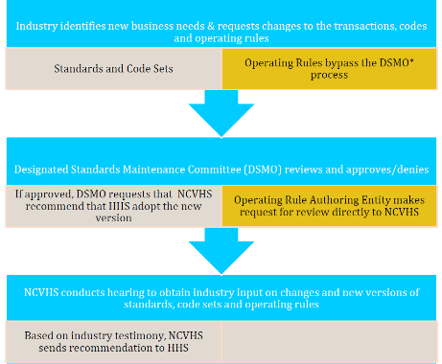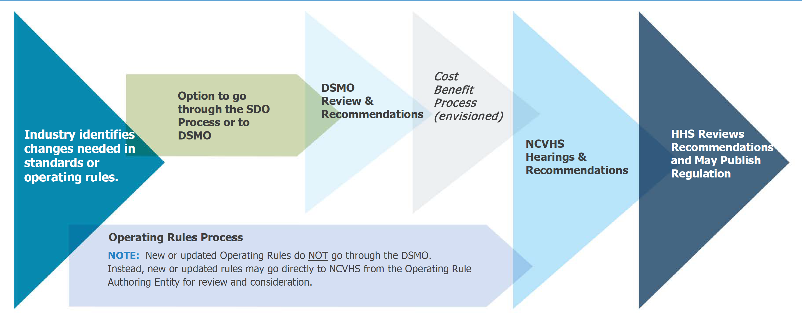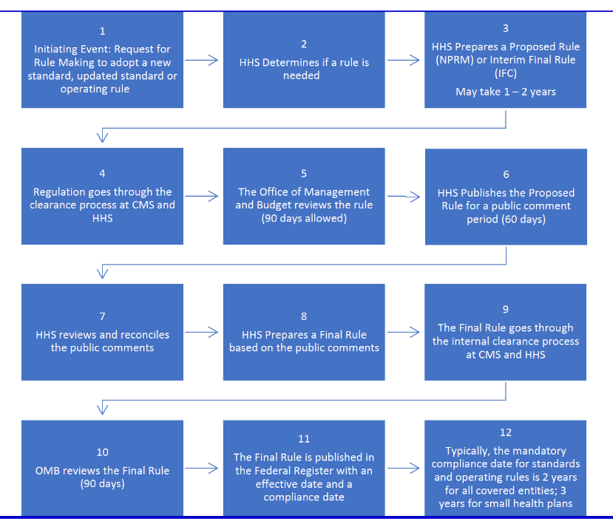
We point this out to encourage the Subcommittee to consider how these pictures, when combined, might reflect smaller, iterative processes, with concurrent testing and implementation. Short of such a move, it may be difficult to provide a path that is predictable, viable, and addresses the need for responsiveness with the appropriate balance of stability and support for innovation.

Simplify and Unify Stakeholder Engagement
As an organization that is both a stakeholder and one that supports the engagement of other stakeholders, our perspective is that rather than failing to offer opportunities for engagement, the current processes tend in the opposite direction, offering a proliferating array of overlapping or redundant and confusing opportunities to enter into and have an impact on the process. Again, with the caveat that the HL7 SDO process is the one that we know best, our view of engagement looks like the following figure.
Figure 2: Stakeholder Engagement in Standards Rulemaking, Current State

In this picture, the stakeholder with a direct interest in the shape of an eventual standard/rule may need to follow the course of the proposal through each stage, tracking potential changes and providing input at each stage. If the interest is in an area that may cross SDO/OE boundaries, as is the case for example, for demographics, medications, problems, and many other data elements, the requirements for engagement can proliferate across SDO/OEs, increasing the level of attention required.
This prospect is overwhelming for all but the most well situated interests. In some cases, professional organizations have a commitment to representing member interests along the full trajectory. Increasing the ease with which such proxy organizations can do so would be a powerful addition to the Education & Outreach recommendations, perhaps learning from those organizations who have had the most success in doing so.
The Subcommittee may also wish to consider this how this picture might be altered, and simplified, under our suggestion to move to concurrent, continual development and test.

Define the Philosophical Sweet Spot that Balances Stability with Innovation
We suggest that the path to predictability requires industry consensus on the correspondence between the degree of change/innovation and the degree of review it requires.
We suspect this is what the Subcommittee may have contemplated in recommending the publication of “baseline” standards. Presumably, non-baseline standards would not require new regulation. Where the Subcommittee may land on this question will drive, to a large degree, the potential to shorten the timeline from requirement to implementation: if more permissive, a shorter timeline can be achieved; if less permissive, the timeline extends because the consequences are greater.
Taken to the extreme, this can become a negatively reinforcing cycle where regulation is so stringent that all parties require hyper-vigilance, which extends the timeline, which increases the pressure to “get it right”. Conversely, a looser interpretation of what requires full review can make it easier to provide that review and achieve publication.
We suggest that the roadmap be based on an approach to HIT standards that takes a position on satisfaction of local vs. global requirements; looser vs. tighter regulations with corresponding longer timelines for major changes vs. radically shorter timelines for minor changes.
Coming to such an agreement in a manner which could provide consistency across SDOs/OEs is a non-trivial task, however, the process of doing so may surface opportunities for alignment among the entities.

Create a Business Model Founded on Greater Collaboration between SDOs and Regulators
We recommend that open (cost-free) access become a condition of government recognition of a standard via regulation and of government support for standards activity. Having served on the Board of Directors of HL7, we are well aware of the struggle to define and sustain a business model where the primary product is created by volunteers and the market demands that it to be provided without cost. We have no silver bullet to aim at this target other than to surface it as a concern that must be shared with regulators who depend on the work committed under the SDO banners.
In our work with HL7 we came to see the acquisition of requirements as the most valuable input that a stakeholder can provide. We view regulators, in this light, as a stakeholder along with private industry, feeding requirements to the SDOs. We would like to see an agile process emerge from this work with continual test and development that supports a collaborative approach in which effort is not duplicated across entities and the role of the SDOs is recognized as service to all stakeholders. This would depart from the current model where government requirements may not be directly conveyed to an SDO and the resulting published standard may require additional layers of standardization via regulation. This should become a single process with greater coordination, collaboration, and mutual support.

What is the value proposition of each recommendation and what improvements to the current state do you believe will arise from each recommendation/group of similar recommendations?
We suggest that the test and development we have stressed in our comments should include rigorous evaluation of cost and benefit to all stakeholders. Test, today, where it occurs, focuses on “is it technically sound?” to the exclusion of “what impact does this have on care delivery? On the business of healthcare?”.
Until we see these other areas as required, concurrent measurements, it will remain difficult to assess a value proposition that speaks to the industry as a whole. Perfect standards and elegant regulations that break business models and disrupt care delivery cannot succeed.

Are there potential unintended consequences? What are those and how can they be mitigated with modifications to the recommendations?
We find that there are always unintended consequences. Overall, we can say that one benefit of the shift to an agile framework could be earlier detection of unintended consequences, rendering them easier to address.
Among the recommendations here, the one we perceive with the highest risk of an unintended consequence is the recommendation for a new entity replacing the DSMO. Without a detailed design for the entity, including vision/charter, makeup, how staff/participation is determined, along with the mandate and authority, it is unclear how it will avoid the issues underlying the DSMO.

Post-Hearing Comments
These comments follow on verbal remarks presented by participants, including Liora, at the December 12-13 hearing of the Subcommittee on Standards.

Modeling agile standards development and implementation
In our initial comments we suggested adoption of a more agile, versus waterfall, approach. This theme was prominent during the day and a half hearing, being voiced and amplified by several participants. Given the difficulty weighing the role of regulation and of industry-initiated efforts, we suggest that a useful first step might be to create a model or several models of how “agile standards development and implementation” might look, understanding that here, the government is not only a regulator, but also a key stakeholder.
Such a model could become the focal point for discussion and eventually evolve into a requirement of a proof of concept project.

Integration of administrative and clinical content
The narrative Brief History and Draft Recommendations notes that “As experience in use of health IT grows, and the convergence of the systems for administrative and clinical data evolves, the need for predictability and the ability to innovate has increased.” (p.7) At the hearing, this very convergence was mentioned by William W. Stead, MD, NCVHS Chair as possibly contributing to a lack of clarity over where information should live – in a transaction or in a clinical API, message, or document – and that this lack of clarity was one possible cause of the difficulty moving to the next generation of HIPAA standards. We concur strongly with this observation and suggest that it become the basis for analysis and assessment.
The assessment would review the evolution of requirements layered onto the X12 transaction sets for electronic claims processing and report on what the evolution reveals in terms of potential overlap or lack of clarity in the basic function of the transaction set against increasing potential for alternate (and more prevalent) methods of access to clinical information.

Addressing heterogeneity among stakeholders
There was much discussion at the hearing on the different levels of capability/technical sophistication among stakeholders and the need to ensure that all will have the capability to deploy new standards as they are released and, eventually, required. Here, we suggest that the Subcommittee consider this disparity as a multidimensional question: on one axis the differing levels of HIT infrastructure and on another the demands of localization which introduce optionality or extensibility into data standards. The issues are distinct in their genesis and in their resolution.
There are many examples of distinct levels of infrastructure found today. These include the presence/absence of an EHR and where there is an EHR, the degree to which it is integrated with Practice Management software. Capacity for management of standard terminologies is another key differentiator across the industry, with all but the larger players having little to no capacity apart from public utilities such as the National Library of Medicine Value Set Authority Center.
Examples, on the other hand, of the second axis, include the unbounded set of local requirements stemming from state, enterprise, and specialty-related requirements such as immunization and BMI information for pediatrics or activities of daily living scales for geriatrics; facility locator codes; and local insurance requirements.
We find it essential to disambiguate these two types of heterogeneity when discussing the perennial question of “how standard” a standard needs to be. Where the first aspect is in question, an incremental approach that allows everyone to participate and incentivizes increased capacity can be effective. In the latter, a scalable and flexible information architecture is required where local variation is anticipated and does not break an otherwise prescriptive model, at any level of complexity.

Incomparable comparisons
Finally, we hope to express our appreciation for the magnitude of the task assumed by the Subcommittee and accompany it with a comment on incomparable comparisons and expectation setting. While comparisons to ATMs and Wifi and numerous other highly functional systems that run well on the basis of communications and data standards are useful, we find there is no domain or problem set that approaches the complexity of the health information domain where clinical information plays even the smallest role. From our background, we have some familiarity with data standards for publishing, semi-conductor manufacturing, early electronic funds transfer, and others. None compare in extent, rate of growth, variability to any single branch of medicine and healthcare delivery.
This singularity should not be lost in the pursuit of improved interoperability and information-driven decision making.
One key outcome of keeping the singularity in mind would be maintaining the centrality of narrative along with the continued expansion of coding and classification systems/ontologies. There are real, practical limits to the degree to which information can be coded and classified as it is captured and greater limits to the degree to which such coding and classification can be standardized across systems and this limit is not unique to healthcare. Real estate and finance, while standardized on forms and transactions, continue to function with the support of large document management systems that, as yet, have had little to no mindshare as key applications within healthcare standards initiatives.

See our articles and blogs for examples of our implementation work: - Z. Gonzaga, EHR-Compatible Pharmacist Care Plan Standard Opens the Door to Cross-Setting Data Exchange, Healthcare Informatics (9/14/2018). https://www.healthcare-informatics.com/article/interoperability/ehr-compatible-pharmacist-care-plan-standard-opens-door-cross-setting-data - K. Sethi,“Reduce Provider Burden by Rethinking the eCQM Development Process,” Lantana Blog (11/14/2018). http://www.lantanagroup.com/2018/11/14/reduce-provider-burden-by-rethinking-the-ecqm-development-process/ - S. McIlvenna, “Pleasant surprise with open-source development,” Lantana Blog (5/2/2018). http://www.lantanagroup.com/2018/05/02/pleasant-surprise-with-open-source-module-development/ - C. Thompson, “Reporting Into the Antimicrobial Use and Resistance (AUR) Module,” Lantana Blog (2/16/2018). http://www.lantanagroup.com/2018/02/16/overcoming-reporting-challenges-with-the-antimicrobial-use-and-resistance-aur-module/ - L. Perrine, “Notes from the Field,” Lantana Blog (5/26/2017). http://www.lantanagroup.com/2017/05/26/notes-from-the-field/ - R. Geimer, “CDA in the Wild” series, Lantana Blog (2016-17). http://www.lantanagroup.com/tag/cdainthewild/

